**THE STATE UNIVERSITY OF ZANZIBAR**

**(SUZA)**



***SCHOOL OF COMPUTING AND MASS MEDIA (SCMM)***

***DEPARTMENT OF COMPUTER SCIENCE AND INFORMATION TECHNOLOGY***

***REPORT OF PRATICAL TRAINNING***

***A report of Practical Training in fulfilment of the requirement for the Bachelor of Information Technology with Management at The State University of Zanzibar (SUZA).***

***Supervisor***

***DR HUSSEIN SHAABAN KHAMIS***

***…………………………….***

***KHAMISI KHALIDI ABDALLAH***

***BITAM/9/21/012/TZ***

***The State University of Zanzibar***

***December, 2023***

# 

# CERTIFICATION

The undersigned certify that they have read and here by recommend for acceptance by the State University of Zanzibar a research entitled: Student’s Report of Practical Training in fulfilment of the requirements for the Bachelor of Information Technology with Management (BITAM) of The State University of Zanzibar.

……………………………………………………………………………………

***DR HUSSEIN SHAABAN KHAMIS***

(Supervisor)

Date: ……………………………………………………….

# ACKNOWLEGEMENT

First and foremost, I am going forward give my sincere thanks to the Almighty Allah, he has guided me from the very first day that I had started, and I thank him for wishing me strength, knowledge and power. Thank you Allah.

The whole season of Practical Training from the beginning to the end was unforgettable historical activity. With some of the contribution and support of those people who were my closeness, I have been able to bring this knowledge where it reached.

My special and innermost gratitude goes to my Project supervisor Mr Ally Ramadhan A, Rai , Mr Salim, Mr Salim and Mr Hamza for accepting being my supervisors and trainers for the time that I was working in my Practical Training. I thank them for being ready to give their time and efforts. They were kind to us, ready to advise, encourage and motivate the moment of the Practical Training. Their supervision guides were remarkable and nothing to pay them but little payment is to say “Thank you so much”.

# ABSTRACT

The main objective of this PT was to build myself and be ready to the world of IT solution in our country and be a problems solver when my knowledge needed to be applied in the field. The PT was not quite good as I expected it would be before, sometimes I keep on telling myself, I have faced those problems because of I am new in the PT programs that is why I felt that ways. But the big problem during my PT activities was a proper task management, there was no proper task given it have been changed particularly depending on the supervisor presented at that time, also the Technology required to complete the task we are not familiar with even though there were trainers available and as students we aren’t able to understand many things at a time, we had no more speed to finish the task soon. During the implementation questions and answers techniques I used them often, and my aims were successful even though I was not satisfied with some answers and this is because of the level of technology in organisation. The main achievement during PT, is that now I have a self confidence that I can work in any other company associate with IT solution and I can do better. Here are my recommendations and suggestions to the organization, they have to buy more tools and equipment and they should arrange their schedule for PT student’s properly.

# TABLE OF CONTENT

Contents

CERTIFICATION i

ACKNOWLEGEMENT ii

ABSTRACT iii

TABLE OF CONTENT iv

LIST OF CHARTS v

LIST OFABBREVIATIONS vi

CHAPTER ONE 7

Introduction 7

Student Background 7

General Objectives of Practical Training(OPT) 2

CHAPTER TWO 3

Organization Background 3

Type of business/ organization 4

Location 4

Organization Structure 5

Number of employees 6

Activities 6

Strategic direction, Mission and Vision 6

**CHAPTER THREE** 7

Activities Performed 7

Poster Design 7

CHAPTER FOUR 10

CONCLUSION 10

Lesson learned 10

SOLUTION FOR THE PROBLEMS 11

Recommendation 11

Recommendation concerning handling gaps placement process 12

TABLE OF FIGURE

Figure 1 Organzation 4

Figure 2 poster design 7

Figure 3 photoshop 8

Figure 4 poster 8

Figure 5 Canva software 9

Figure 6photoshop 9

Figure 7 Premiar pro 10

Figure 8 Premiar pro 10

# LIST OF CHARTS

Charts 1: SUZA Organization Structure 5

# LIST OFABBREVIATIONS

**PT:** Practical Training

**IT:** Information Technology

**HTML:** Hyper-text mark-up language

**OS** Operating System

**BITAM:** Bachelor of information Technology And Management

**SUZA S**tate University Of Zanzibar

**ZIToD** Zanzibar Institute of Tourism Development

**OPT**  Objectives of Practical Training

**CHS** College of Health Sciences

# CHAPTER ONE

## Introduction

Practical Training (PT) is the short period where students go to different organisation to gain their knowledge by working as normal workers and the main reason for this Practical Training is to prepare the students to be ready to work anywhere in the world once when they finish their study, the main purpose of PT to let students to apply the knowledge which they study theoretical and the them for actual practical. There are many types of PT this due to the field study of a particular student but in Information Technology, you may take PT in Web Design, Programming, Networking and Graphic Design.

## Student Background

My name is Khamisi Khalidi Abdallah, I am current student at The State University of Zanzibar taking Bachelor of IT with Management, I started to study in October 2021, and this is my fSecond year of study, the whole year was very wonderful with a lot of challenges in both semesters but in second year was really cumbersome due to the most of the subjects needed more practically and as a student you need to make extra efforts on your own so as to make you perfect on your subjects.

At 31st of July 2023, this was the end of my first year second semester examination, I barely knew nothing on how and where I can apply my knowledge but when I accepted to take PT short program I started to see the light of really world and how important we are in our society because it depends on us to bring good things, I started to attend the course on 31st of July, I only stayed a one week at home after finish my second semester final exams, at the first day everything were black and white in my mind because I realise everything were not as I thought before how could be but I did not give up on that, I kept on asking so many questions until I got big picture in my mind on how things managed, as normal for any student of any field for the first two weeks, things were not going so well me I had many things to learn for a short period of time, and this feeling made be unhappy for somehow I had to use more internet googling for what I wanted to know and that attitude made me be an addicted for internet only because I want to learn new things more and more.

## General Objectives of Practical Training(OPT)

The main objectives of this PT were to make and prepare students to have a little knowledge and experience on how things are done in a really world, because this helped many students who done it before because made them perfect suit in their job post and others solved many problems in the society.

But that were not only the objectives of PT, to inspire students to love what they are doing and make them to believe themselves that they can apply their knowledge in any field from anywhere only they have to do exactly as what they have to do and from that they might be their source of income and not only depend on to be employed from the Government or any big organisation.

# CHAPTER TWO

## Organization Background

The State University of Zanzibar (SUZA) was established by Act No. 8 of 1999 of the Zanzibar House of Representatives which was then amended by Act No. 11 of 2009, and further re-amended by Act No. 7 of 2016. The latter amendment has justified SUZA to merge with other Zanzibar higher learning institutions; these are the then Zanzibar Institute of Financial Administration (ZIFA), College of Health Sciences (CHS) and the Zanzibar Institute of Tourism Development (ZIToD). His Excellency Dr Ali Hassan Mwinyi, the President of Zanzibar and Chairman of the Revolutionary Council is the Chancellor of the University. The University became operational in September 2001.

Currently, SUZA consists of nine campuses that are found at equally beautiful but different locations within the islands. Six campuses are located in Unguja and one campus in Pemba Island. Tunguu is the main SUZA campus located about 12 km away from Zanzibar town. The campus is actually huge and brand new decorated with green field that offers cutting-edge infrastructure of the World standard. It gives to students a local alternative to some of the world’s attractive learning environments.

The second campus is inherited from the first Teachers’ Training College in East Africa, Nkrumah campus at Beit el Ras. This is located along the coast of the Indian Ocean 5 kilometres away from the Stone Town; Nkrumah is a unique and unparalleled campus in the region that is constantly and naturally decorated by glittering blue sea and white sand beach along the perimeter of the campus. Here, our students enjoy very enriching learning environment along with the sea breezes.

Vuga as the third campus is located in the heart of the famous and historic Stone Town. Zanzibar is proud of this campus and it is very magnificently conserved by UNESCO World heritage site that vividly manifests rich culture and history of Zanzibar and its people. Thus, Vuga campus is composed of old but well-kept historic structures that are surrounded by social amenities and public offices.

Benjamin Mkapa as the fourth Campus is located in Mchangamdogo at Pemba Island. This campus is inherited from the Benjamin Mkapa Teachers’ Training College. The fifth Campus is Maruhubi which is situated along the Indian Ocean sea shore 4 kilometres away from the town centre, and 14 kilometres away from Zanzibar airport. To reach public and private transport is readily available at a reasonable cost.

Chwaka is the sixth Campus located at Chwaka village; scenic fishing village in Central District 30 kilometres away from Zanzibar town.

The seventh Campus is inherited from the then College of Health Sciences at Mbweni.

The eighth Campus is at Kizimbani

The ninth Campus is at Maruhubi.

More new campuses that will house new schools are expected to be built in the next few years in accordance with the university strategic plan. These will be located in both, Unguja and the sister island of Pemba and at Tanzania Mainland.

As an academic public institution, SUZA commits to deliver quality education to transform society to be well educated, to acquire responsible leadership and practical entrepreneurial skills, and to adopt democratic citizenry. Most importantly, SUZA fully contributes in preparing and shaping future leaders of the country both in private and public sectors. At heart, SUZA strives to fully contribute towards establishing a sustainable society amidst the ever emerging new challenges of the 21st century and challenges of the future.

SUZA aims at elevating its reputation even higher. In addition to its reputation in offering quality education, SUZA strengthens its research undertake in order to globally contribute in generating new knowledge and thus, answering difficult questions that puzzle the world today.

## Type of business/ organization

The type of this Organisation is a Government organisation (Public)

### Location

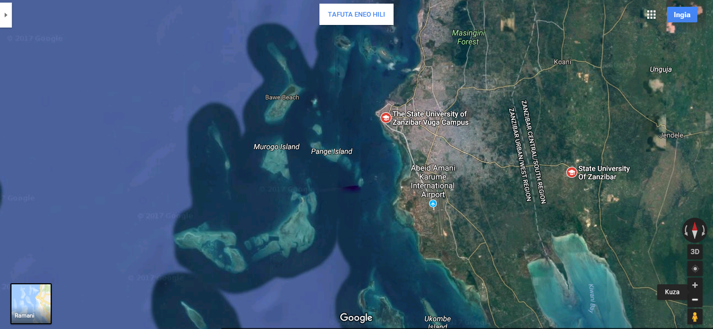

Figure Organzation

[**http://suza.ac.tz/**](http://suza.ac.tz/)

The State University of Zanzibar (**SUZA**), locate at Tanzania, Zanzibar Urban/West, from Zanzibar City

### Organization Structure

SWU

PPU

PMU

SNSS

DHR

DF

DPS

CICTS

SKFL

SOE

SHMS

SCOPE

Council

VC

PRU

AFRU

DVC (ADM)

LU

IAU

DAQA

DVC (AC)

DLS

CGSR

GCSCS

TRCOEM

Charts : SUZA Organization Structure

### Number of employees

### Activities

* Lecturing
* Library Services
* Projects and Researches
* TV Broadcasting

### Strategic direction, Mission and Vision

#### Vision

To be the preferred higher institution of learning and research in Eastern Africa.

#### Mission

To offer quality and broadly relevant education and research in order to develop a knowledge-based

On society that can tackle the challenges of 21st century and beyond.

# **CHAPTER THREE**

## Activities Performed

## Poster Design

This task was wonderful job because of the knowledge what I had was different from that I have achieved from this task, once I only had no knowledge of poster design and development. I achieved in learning Photoshop,

But everything has some good and bad out comes.



Figure poster design

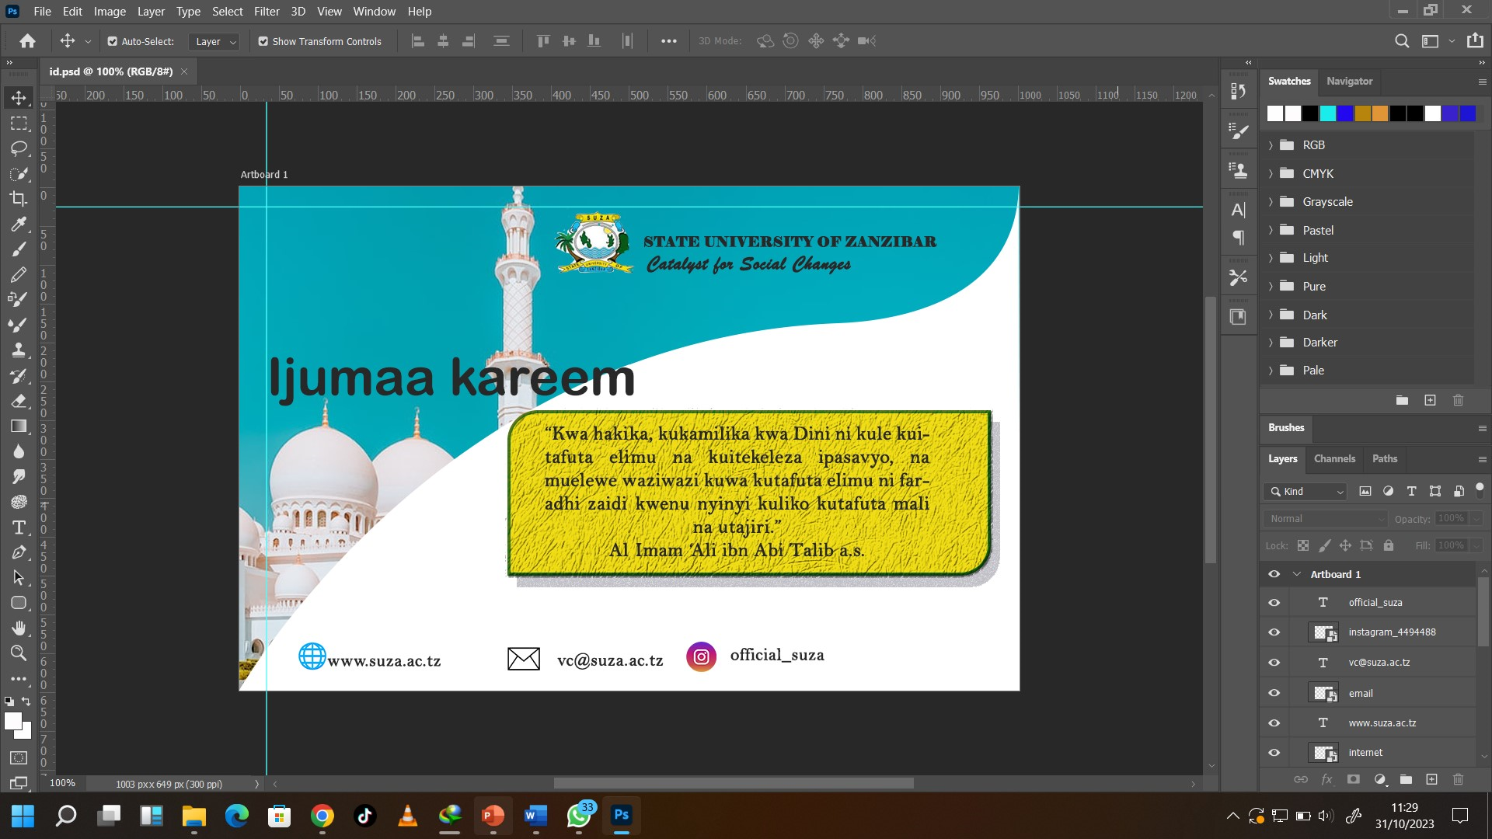

Figure photoshop



Figure poster



Figure Canva software



Figure photoshop

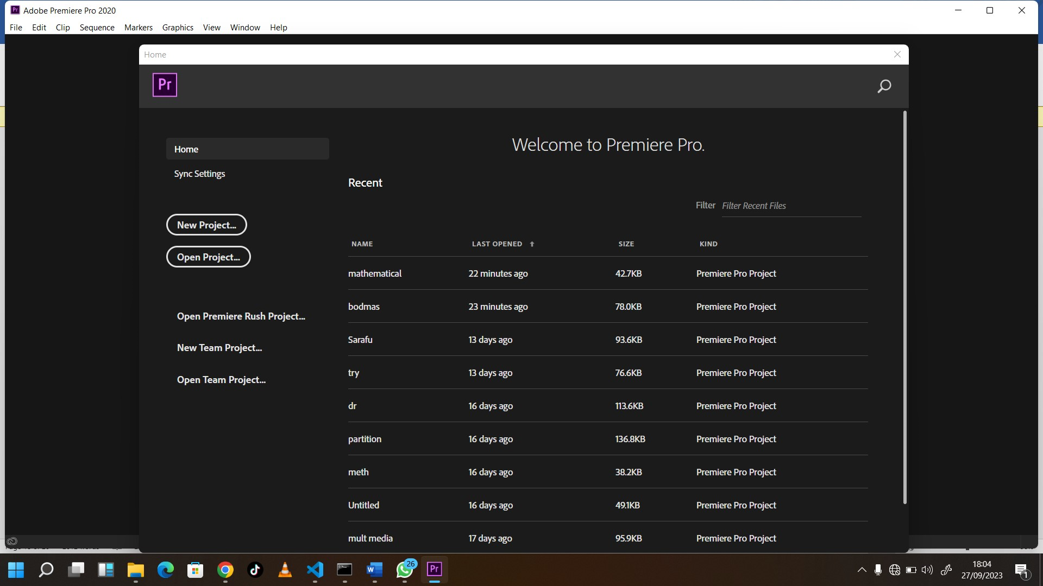

Figure Premiar pro

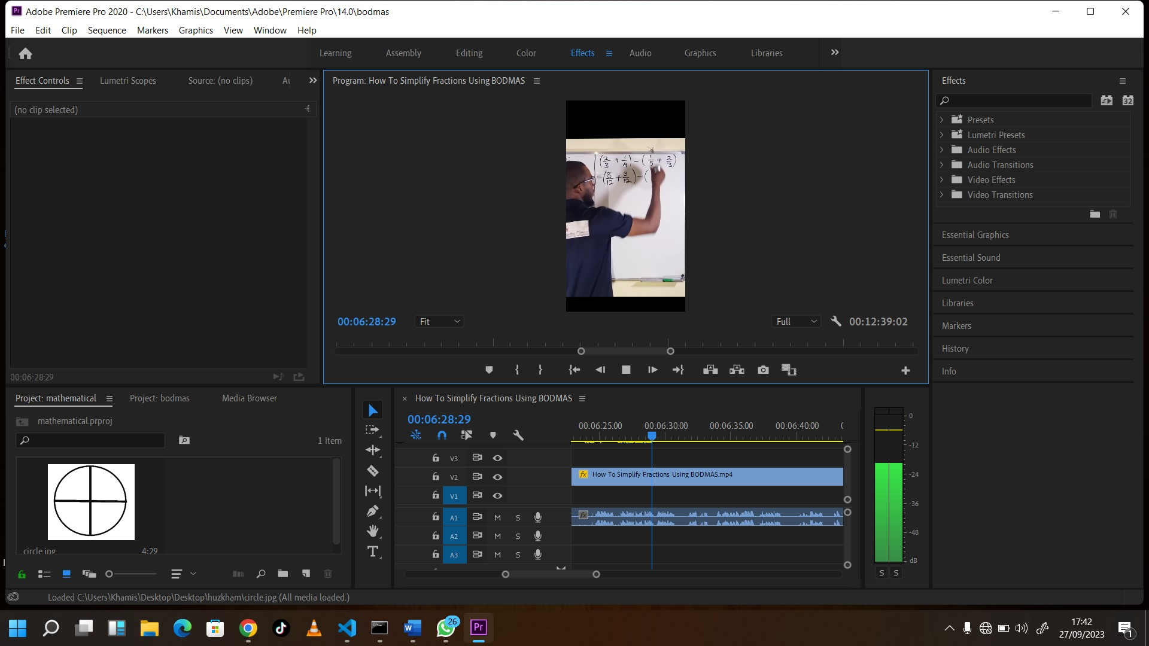

Figure Premiar pro

* **Good**
* Ease to use
* Ease to design a logo and poster using mac os
* Have many features
* Its require few time to complete big projects
* **Bad**
* Very Expensive
* Use high technology
* Payment System used to buy not common in Tanzania
* Some has low security
* And some require high internet

# CHAPTER FOUR

## CONCLUSION

## Lesson learned

* Poster design using Adobe Photoshop and Adobe illustrator
* Preparing ticktok video using Adobe premier pro
* Learning on how to use different tools in Premier pro
* Learning on how to prepare Script
* How to do things in groups/ teams

**New thigs which I have learned**

* Designing poster
* Designing id card and other card
* Preparing video
* Learn on how to prepare different logo
* Learn different tools in Adobe photoshop premier pro and other software
* Learn on using online soft ware like canva software
* How to prepare camera from start up to end

**Problems faced during PT**

I admit that I have faced many problems during my PT course and this I can describe because of many things were new thing to me which I had no any clue earlier.

Another problem I have faced during my PT, when I was learning logo and poster design, if you want to create a wonderful poster you can do whatever you want with these but the problem it comes when you want to do so, you have to install plugs in and themes, there are some available for free of charge but other require high quality internet connection which is poorly available in SUZA and sometime you have to use your own internet bundles its very expensive not everyone can afford to pay for them especial or people who are still learning.

Not only that but also the technology which we were supposed to use for web development for our project given was new and the information were given almost at the end of PT periods, hence many groups can’t fulfil their project work.

## SOLUTION FOR THE PROBLEMS

* Ask questions to supervisor and other expert
* Try to use free sources
* Make sure you have your own devices to do more practice outside field area
* Do activities in team in order to learn new things other team members
* Try to maintain the time properly
* Be prepared for any changes at any time
* Prepare yourself mentally, physically and financially

## Recommendation

The University should increase the equipment and facilities for students to learn, like computers, because not all university students can afford buying computers of their own, and with much practical make the students even better, but without it the students will have knowledge but they will not have the ability of doing work.

## Recommendation concerning handling gaps placement process

The university should process the application letters for the training placement as early as possible so as to allow the students to apply in early time the places they want for the field, because when they late some of the students don’t get a chance to do it in the best and trusted industries.